Wells College

[Company name]  [Company address]

**Contribute to organizational privacy and contingency plans**

|  |  |  |  |
| --- | --- | --- | --- |
| Name of Student | Jonathan Tanuwijaya | ID | 18399 |

# Assessment 2- Research

#### Instructions

This is an in-class closed book written assessment. Answer all the questions on the paper provided by your Trainer.

Contents

Assessment 2- Research 1

Duration: 1

Task 1-Multiple choice Questions: 2

Index 10

### Duration:

Trainer will set the duration of the assessment.

### Image result for intellectual property rightsTask 1-Multiple choice Questions:

1. Intellectual Property Rights (IPR) protect the use of information and ideas that are of
   1. Ethical value
   2. Moral value
   3. Social value
   4. Commercial value

Refer: <https://www.ipaustralia.gov.au/understanding-ip>

Intellectual property (IP) is the property of your mind or proprietary knowledge. Basically, the productive new ideas you create. It can be an invention, trade mark, design, brand, or the application of your idea.

Comment: it is important commercial value to help your business.

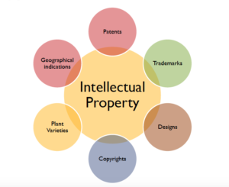

1. The term ‘Intellectual Property Rights’ covers
   1. Copyrights
   2. Know-how
   3. Trade dress
   4. All of the above

Intellectual property rights are the rights given to persons over the creations of their minds. They usually give the creator an exclusive right over the **use** of his/her creation for a certain period of time.

Refer: <https://www.wto.org/english/tratop_e/trips_e/intel1_e.htm>

Comment: IT could help the people make more new creation and contribute more for society.

1. 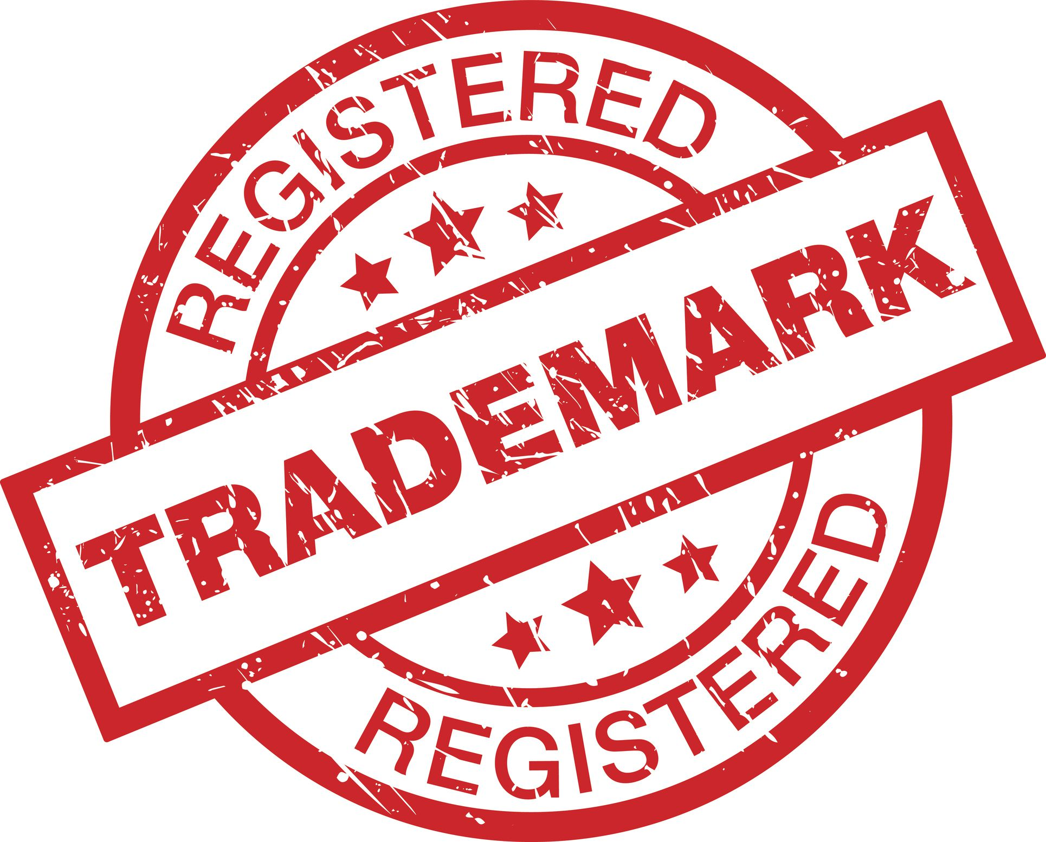The following cannot be exploited by assigning or by licensing the rights to others.
   1. Patents
   2. Designs
   3. Trademark
   4. All of the above

Refer text book: Intellectual property includes copyright of publicly available material, but also extends to less tangible assets and knowledge, such as patents, trademarks, designs, trade secrets and ‘know-how’.

Comment:

If you want to protect your business name, brand names, logo or catchphrases from being used by others, you need to register a trade mark. Best protect your business is using Trademark

Please refer: <https://sprintlaw.com.au/lp/register-your-trade-mark/>

1. 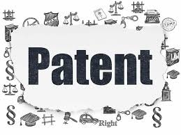The following can be patented
   1. Machine
   2. Process
   3. Composition of matter
   4. All of the above

Refer: <https://en.wikipedia.org/wiki/Machine_(patent)>

**machine** is one of the four principal categories of things that may be patented. The other three are a process (also termed a [*method*](https://en.wikipedia.org/wiki/Method_(patent))), an [article of manufacture](https://en.wikipedia.org/wiki/Article_of_manufacture) (also termed a *manufacture*), and a [composition of matter](https://en.wikipedia.org/wiki/Composition_of_matter).

Comment: machine and composition of matter are patented. Process could be thought is part of patented. So the best answer is d.

1. 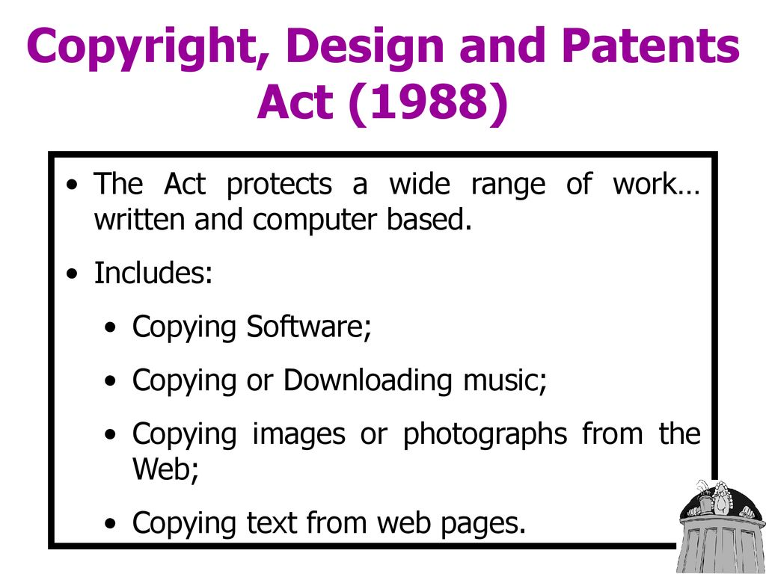Which of these rights isn't generally regarded as part of designs law?
   1. Registered designs law
   2. Copyright
   3. Trade mark law
   4. Design Right under Part III of the CDPA (copyright, designs, patents act)

Refer: <https://en.wikipedia.org/wiki/Copyright,_Designs_and_Patents_Act_1988>

The Copyright, Designs and Patents Act 1988, also known as the CDPA, is an Act of the Parliament of the United Kingdom that received Royal Assent on 15 November 1988.

Comment: select a, b and d all under the CDPA, but trade mark law not part of designs law.

1. To enforce copyright to prevent a product from being copied:
   1. The claimant's product must be represented in an artistic work.
   2. Articles made to the design must have been marketed.
   3. The defendant's product must be a substantial copy of the claimant's product.
   4. The claimant's designer must have created the design for the claimant's product in the form of a drawing or a model that is an artistic work.

Refer: <https://www.coursehero.com/file/78016311/TEST-3docx/>

Comment: creating the design in a tangible form is important for establishing copyright, it is not sufficient by itself for enforcing copyright without the substantial copying by the defendant.

1. Copyright law protects:
   1. Tangible property.
   2. Intangible property.
   3. The name of a particular good or service.
   4. Ideas contained in varied forms of expression.

Refer: <https://www.infrastructure.gov.au/sites/default/files/short_guide_to_copyright.pdf>

Comment: Copyright law does not protect tangible property (physical items); it protects the expressions of ideas fixed in a tangible medium.

1. While sharing some similarities, committing plagiarism and violating copyright are different because plagiarism involves:
   1. Using someone else's work as if it were your own.
   2. Distributing someone else's work.
   3. Reproducing someone else's work.
   4. All of the above.

Refer: <https://www.plagiarism.org/article/what-is-plagiarism>

Comment: Plagiarism is the act of presenting someone else's work, ideas, or expressions as your own without proper attribution.

1. The exclusive rights that apply to copyright owners include the right of:
   1. Public distribution of the work.
   2. Reproduction of the work.
   3. Preparation of derivative works.
   4. All of the above.

Refer: <https://www.infrastructure.gov.au/sites/default/files/short_guide_to_copyright.pdf>

Comment: These rights include the right to copy, publish, communicate (e.g. broadcast, make available online) and publicly perform the copyright material.

1. Before a copyrighted work like a book may be printed:
   1. The book must be registered with the Copyright Office.
   2. Consent of the copyright owner must be obtained.
   3. The copyright symbol must be affixed to the book.
   4. None of the above.

Refer: <https://www.infrastructure.gov.au/sites/default/files/short_guide_to_copyright.pdf>

Comment: To prevent copyright infringement, the consent of the copyright owner must be obtained for any use of their work. This involves getting permission before reproducing, distributing, performing, publicly displaying, or creating derivative works based on the copyrighted material.

1. Excluding "work for hires," a sole-authored original work created after 1978 receives copyright protection for:
   1. 56 years.
   2. 95 years.
   3. 67 years.
   4. The life of the creator plus 70 years.

Refer: <https://www.quora.com/Which-type-of-movie-has-no-copyright?top_ans=51199314>

Comment: Works created after January 1, 1978, receive copyright protection for the lifetime of the author plus 70 years. If the work is a joint creation by multiple authors, the term lasts for 70 years after the last surviving author's death. For works made for hire, anonymous works, or pseudonymous works, copyright protection lasts for 95 years from the date of publication or 120 years from the date of creation, whichever is shorter.

1. The Digital Millennium Copyright Act (DMCA):
   1. Provides exemptions from copyright infringement claims to Internet service providers (ISPs) who are merely acting as conduits.
   2. Establishes compulsory licensing for the transmission of music over the Internet.
   3. Prevents the circumvention of technological measures designed to protect copyrighted works.
   4. All of the above.

Refer: <https://www.copyright.gov/legislation/dmca.pdf>

Comment: The DMCA resolved that by first making it a violation to circumvent a technological measure to access a copyrighted work, and then making it a violation to traffic in devices whose purpose is to circumvent the technological measure to either access the work or otherwise infringe the copyright.

1. Basil is a designer who works for Meteor Motors Ltd, a company which manufactures specialist sports cars which are built on a timber frame. For a forthcoming press release about a new model of car (the Meteor Merlin), Basil made a three-dimensional space-frame replicating the new revolutionary timber frame to be used for the Merlin. He built it from engineering drawings using balsa wood (a very lightweight wood which possesses little strength but is useful for modelling) with glued joints. The real cars will be built using a strong ash frame with sturdy bolted joints. Which one of the following best describes Basil's balsa wood and glue space-frame from a copyright perspective?
   1. It is not protected by copyright as copyright does not protect industrial designs
   2. It is not an artistic work on the basis of being a sculpture or a work of artistic craftsmanship.
   3. Anyone copying the space-frame will infringe the copyright in the drawings indirectly as these are protected irrespective of artistic quality
   4. As the space-frame will not be seen in normal use of the Merlin, being covered by metal panels and body parts, there can be no artistic copyright (which requires eye-appeal) in the frame nor in the drawings as these lack artistic quality, being engineering drawings

Refer: <https://www.artslaw.com.au/article/i-like-your-style-part-i-copyright-infringement-or-not/>

Comment: for a work to qualify for artistic copyright, it needs to be aesthetically pleasing and intended to be appreciated visually, which engineering drawings and hidden components usually are not.

1. Roger is a computer programmer and is employed by a software development company known as Programmers R Us Ltd. A retail organisation known as Acme Trading Ltd asked Programmers R Us to write some computer software to handle Acme's accounts and paid Programmers R Us a fee of £87,500 for the work. All the work was carried out by Roger at Acme's premises and on Acme's computer during a period of 10 months. Roger was paid an hourly rate (£17.25 per hour) by Programmers R Us for his work on the project. There is nothing in writing to say who owns the copyright subsisting in the computer software and there is no written assignment of copyright. There is no express or implied agreement as between Roger and Programmers R Us as to copyright ownership. Which one of the following most accurately describes the position as regards ownership of copyright in the computer program?
   1. Roger owns the copyright at law and at equity as he created the software. Any presumption that his employer, Programmers R Us owns it is displaced because he created the software at Acme's premises and using Acme's equipment
   2. Acme Trading Ltd owns the legal and beneficial copyright in the software because it paid for it to be written, there was no agreement to the contrary and Programmers R Us owes a fiduciary duty to Acme
   3. As there was no formal assignment of copyright complying with the Copyright, Designs and Patents Act 1988, Programmers R Us is the first owner of the legal title to the copyright as Roger created the software as an employee in the course of his employment? However, a court is likely to hold that Acme is the beneficial owner of the copyright or at least has an implied licence to continue to use it

Refer

* 1. Acme Trading and Programmers R Us are joint owners of the legal and beneficial copyright. This will enable Acme to continue to use the software and both Acme and Programmers R Us to licence the software to third parties

Refer: <https://www.legislation.gov.uk/ukpga/1988/48/contents>

Comment: The Act protects the intellectual property of individuals and requires that permission of the owner of the intellectual property is sought before any use of it is made.

1. Naomi MacDonald is a poet who wrote a series of poems on the theme of 'The Four Seasons' for Limerick Publishing plc ('LPP'). Naomi granted LPP an exclusive licence to publish the poems as a collection in book form under the name 'The Four Seasons Poems'. There were no terms in the licence agreement relating to Naomi's moral rights. LPP published and sold the entire print run of 800 copies of the book with Naomi being acknowledged as the author on the cover and flyleaf.

However, LPP decided not to reprint the book and informed Naomi accordingly. Naomi subsequently assigned the copyright in her Four Seasons Poems to Epic Sagas Ltd ('ESL'). A term in the assignment stated that Naomi was to be identified as author under her newly adopted pseudonym 'Helena Campbell'. ESL duly printed copies of the poems and put them on sale. They bore the author's name as Naomi MacDonald as a result of an oversight by ESL's printing sub-contractor. Which one of the following statements is correct?

* 1. ESL is in breach of Naomi's right to be identified as author as she specified the pseudonym 'Helena Campbell' in the assignment and that form of identification only must be used
  2. Although there is potential liability for failing to use the specified form of identification, ESL is not liable as the mistake was that of its printing sub-contractor who will be liable to Naomi for its error
  3. As the book of poems was lawfully first published with the name Naomi MacDonald as author, this overrides any later assertion of the right to be identified as author
  4. There is no infringement of Naomi's right to be identified by author by ESL as using her real name to identify her is a reasonable form of identification

Refer: <https://deakin.libguides.com/copyright-module1/moral-rights#:~:text=right%20of%20attribution%3A%20the%20right,the%20author%20of%20their%20work>.

Comment: Naomi MacDonald's moral right to be identified by her pseudonym 'Helena Campbell' has been infringed by Epic Sagas Ltd (ESL). Despite being a reasonable form of identification, using her real name violates the agreed-upon terms in the assignment contract. The oversight by ESL's printing subcontractor does not exempt them from this obligation. Therefore, the statement that there is no infringement is incorrect. Proper identification in accordance with the author's wishes is crucial in upholding her moral rights

1. Frederick is a well-known commercial artist who is employed by Graphic Designs Ltd ('GDL'). As part of his employment duties, Frederick produced an original drawing depicting an angler fishing from a boat in the process of reeling in a large barracuda fish. The drawing captured the excitement of the event. Frederick's name did not appear on the drawing. GDL assigned the copyright in the drawing to Southern Sports Ltd ('SSL'), which applied copies of the drawing to T-Shirts, which were sold in large numbers to keen anglers. A charitable organisation, Campaign Against Cruel Sports ('CACS') started placing advertisements which include a copy of Frederick's drawing but with the head of the angler replaced by the head of a monstrous devil and to which a slogan had been added stating 'All anglers are sub-human fiends'. CACS did not have SSL's permission to copy or modify the drawing. Frederick was incensed when he saw CACS's advertisement. Which one of the following statements is correct?
   1. If Frederick sued CACS on the basis of the moral right to object to a derogatory treatment of his drawing, CACS would escape liability if it raised a defence based on freedom of expression under Article 10 of the Council of Europe Convention for the Protection of Human Rights and Fundamental Freedoms
   2. As Frederick does not own the copyright in the drawing he has no remedies under copyright law
   3. As Frederick's name does not appear on the drawing he cannot object to the treatment of the work as the right only applies if the author is identified as such on copies of the work
   4. Frederick has a right to object to a derogatory treatment of his work as the modification was not made by or with the authority of the copyright owner providing it amounted to a distortion or mutilation of his drawing or is otherwise prejudicial to his honour or reputation

Refer: <https://humanrights.gov.au/our-work/commission-general/universal-declaration-human-rights-human-rights-your-fingertips-human#:~:text=Article%2010,any%20criminal%20charge%20against%20him>.

Comment: CACS's defense under Article 10 (freedom of expression) might not necessarily exempt them from liability for derogatory treatment of Frederick's drawing. Courts typically balance freedom of expression against an author's moral rights, considering if the treatment significantly harms the author's reputation or the integrity of the work. Thus, Frederick could still have a valid claim despite CACS invoking freedom of expression.

1. In relation to infringement of an original work of copyright, which one of the following statements is not correct?
   1. Substantiality is more concerned with quality rather than quantity, in other words, it is the importance of the part taken to the work that has been copied which is the predominant question
   2. Copyright infringement requires, essentially, three things to be shown (i) that copyright subsists in the claimant's work, (ii) that the defendant has copied from the claimant's work (directly or indirectly), and (iii) that the part copied by the defendant is a substantial part of the claimant's work
   3. The part taken from the claimant's work must be a substantial part of that work but need not be a substantial part of the defendant's work
   4. Where an artistic work is copied by converting it from three-dimensions to two-dimensions, or vice versa, the copy must, in the eyes of a non-expert, look like the work copied

Refer: <https://www.coursehero.com/tutors-problems/Computer-Science/41873994-17-In-relation-to-infringement-of-an-original-work-of-copyright/#:~:text=the%20predominant%20question.-,Where%20an%20artistic%20work%20is%20copied%20by%20converting%20it%20from,with%20the%20importance%20of%20the>

Comment: For an infringement claim to be valid when an artistic work is copied by converting it from three-dimensions to two-dimensions, or vice versa, the resulting copy must resemble the original work sufficiently that a non-expert observer would recognize it as the same. This ensures that the essence and distinctive elements of the original work are maintained in the copy, making it clear that copying has occurred.

1. Privacy in Australia is overseen by:
   1. Australian Security Intelligence Organisation
   2. Australian Securities Commission
   3. The Privacy Commissioner
   4. The Privacy Ombudsman

Refer: <https://www.cookieyes.com/blog/australia-privacy-act/#:~:text=The%20Act%20outlines%2013%20Australian,2010%20to%20oversee%20privacy%20regulation>.

Comment: The Act outlines 13 Australian Privacy Principles for managing personal information and established the Office of the Australian Information Commissioner (OAIC) in 2010 to oversee privacy regulation.

1. The legislation which sets out the rules for privacy in Australia is called:
   1. The Official Secrets Act
   2. The Freedom of Information Act
   3. The Corporations Law
   4. The Privacy Act

Refer: <https://www.ag.gov.au/rights-and-protections/privacy#:~:text=The%20Privacy%20Act%201988%20(Privacy,and%20in%20the%20private%20sector>.

Comment: The Privacy Act 1988 (Privacy Act) is the principal piece of Australian legislation protecting the handling of personal information about individuals. This includes the collection, use, storage and disclosure of personal information in the federal public sector and in the private sector.

1. The Privacy Act applies to whom?
   1. Government departments only
   2. Large corporations only
   3. Private enterprise only
   4. All of the above

Refer: <https://www.oaic.gov.au/privacy/privacy-legislation/the-privacy-act#:~:text=The%20Privacy%20Act%20includes%2013,known%20as%20'APP%20entities>'.

Comment: The Privacy Act includes 13 Australian Privacy Principles (APPs), which apply to some private sector organisations, as well as most Australian Government agencies. Such organisations and agencies are collectively known as 'APP entities'.

1. The Privacy Act is concerned with how all personal information is used and stored. This statement is:
   1. True
   2. False

Refer: <https://www.oaic.gov.au/privacy/privacy-guidance-for-organisations-and-government-agencies/handling-personal-information/guide-to-securing-personal-information>

Comment: the Privacy Act gives you greater control over the way that your personal information is handled.

1. People have rights to access information a company or Government Department holds about them.
   1. True
   2. False

Refer: <https://www.oaic.gov.au/freedom-of-information/how-to-access-government-information/on-accessing-information-under-freedom-of-information>

Comment: can request access to a document an Australian Government agency holds under the FOI Act

1. An organisation should only use or disclose a person's information for the purpose it was collected unless the person has consented to it being used in another way.
   1. True
   2. False

Refer: <https://www.oaic.gov.au/privacy/australian-privacy-principles/australian-privacy-principles-guidelines/chapter-6-app-6-use-or-disclosure-of-personal-information>

Comment: An organisation or agency 'discloses' your personal information if they give access to it, or show it to another individual, organisation or agency.

1. Define morality
   1. What is considered as correct within a society
   2. Making the right decision's where there is a chance to do wrong
   3. Defining what is right and wrong for an individual or a community
   4. Where individuals have a conscious choice to make a right and ethical decision

Refer: <https://study.com/academy/lesson/what-is-morality-definition-principles-examples.html#:~:text=Morality%20is%20the%20human%20attempt,good%20behavior%20or%20proper%20conduct>.

Comment: Morality is the human attempt to define what is right and wrong in thought and behavior, resulting in a system or set of ideas about good vs. bad action, and the basis of any individual or community belief in what constitutes good behavior or proper conduct.

1. What is business ethics?
   1. The study of business situations, activities, and decisions where issues of right and wrong are addressed
   2. Defined as decisions organisations make on issues that could be considered right or wrong
   3. Ethics that can be applied to an organisation’s practises
   4. Ethical processes businesses use in order to achieve a good ethical standard

Refer: <https://www.investopedia.com/terms/b/business-ethics.asp#:~:text=Business%20ethics%20is%20the%20moral,a%20business%20and%20its%20customers>.

Comment: Business ethics is the moral principles, policies, and values that govern the way companies and individuals engage in business activity.

1. Which is not a reason a business engages in business ethics?
   1. To recover a company’s image after a notorious business scandal
   2. To avoid the loss of a good corporate image or being sued for misconduct
   3. To enhance global relationships
   4. To enhance stakeholder relationships
   5. To act with real commitment
   6. To build corporate reputation

Refer: <https://byjus.com/question-answer/which-is-not-a-reason-a-business-engages-in-business-ethics-to-recover-a-companys/#:~:text=To%20enhance%20the%20global%20relationships,exist%20in%20a%20business%20environment>.

Comment: To enhance the global relationships is not a reason why firms tend to engage in business ethics. Business ethics, which is also referred to as corporate ethics, is a form of ethics that focuses on the principles or problems that exist in a business environment

1. Which one is a purpose of Privacy?
   1. protects individuals from misuse of their personal information
   2. protects the rights of owners of published and unpublished material
   3. ensures equal rights regardless of gender, ability, religion or ethnicity
   4. protects the good name and reputation of individuals and businesses

Refer: <https://www.ipc.nsw.gov.au/fact-sheet-consent>

Comment: The purpose of a privacy notice is to provide accessible information to individuals about any proposed use or disclosure of their personal information

1. There are 10 National Privacy Principles. Which of the following is not the privacy principle?
   1. Organisations must give people the option to interact anonymously whenever it is lawful and practicable to do.
   2. Generally speaking, an organisation should not give an individual access to personal information it holds about that individual on request.
   3. An organisation must take reasonable steps to make sure that the personal information it collects, uses or discloses is accurate, complete and up-to date.
   4. An organisation must have a policy document outlining its information handling practices and make this available to anyone who asks.

Refer: <https://www.oaic.gov.au/privacy/australian-privacy-principles/read-the-australian-privacy-principles>

Comment: An APP entity must take reasonable steps to ensure that the personal information it collects is accurate, up-to-date and complete

1. What are the common security features covered in a system’s functional requirements?
   1. log ins
   2. password policies
   3. open public shells
   4. secure directories
   5. encryption protocols

Refer: <https://www.opensecurityarchitecture.org/cms/definitions/it_security_requirements#:~:text=Functional%20Security%20Requirements%2C%20these%20are,practices%2C%20policies%2C%20and%20regulations>.

Comment: Functional Security Requirements, these are security services that needs to be achieved by the system under inspection. Examples could be authentication, authorization, backup, server-clustering, etc. This requirement artifact can be derived from best practices, policies, and regulations.

1. IT support staff loudly discuss their organisation’s network security problem on a crowded train. This statement relate to which ethical issue.
   1. Reliability
   2. Security
   3. Confidentiality
   4. Proprietary rights
   5. Conflict of interest

Refer: <https://csrc.nist.gov/glossary/term/confidentiality#:~:text=The%20term%20'confidentiality'%20means%20preserving,personal%20privacy%20and%20proprietary%20information>.

Comment: The term 'confidentiality' means preserving authorized restrictions on access and disclosure, including means for protecting personal privacy and proprietary information

### Index

B

business name 3

C

computer programmer 5

copyright 2, 3, 4, 5, 6, 7

I

Intellectual Property Rights 2

IT support 10

S

sub-contractor 6

T

trade mark 2, 3